10.68: The tension is related to the acceleration of the yo-yo by 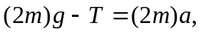 and to the angular acceleration by 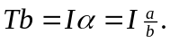 Dividing the second equation by b and adding to the first to eliminate T yields

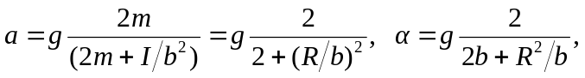

where 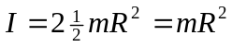 has been used for the moment of inertia of the yo-yo. The tension is found by substitution into either of the two equations; e.g.,

